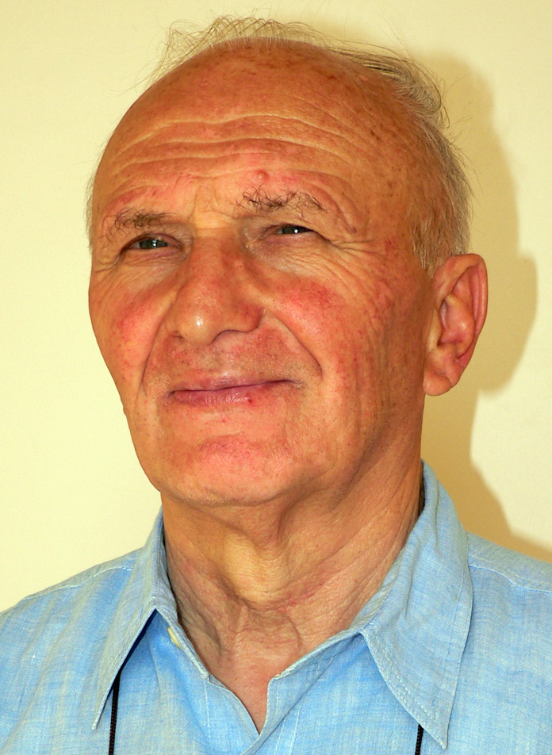
SOCIETY OF ST PAUL
The Secretary General
«As we have been united in the profession of the faith, so let us keep ourselves united in suffrage and intercession.»
(Fr. Alberione)

At 20.20 hours of Thursday, 23 July, at the Nursing Home of the Madonna del Rosario of Catania, has returned to the Father our brother Disciple of the Divine Master

BR. MARCO UGO GIRALDO
82 years: 68 of Pauline life and 58 of religious profession.

Fr. Marco Ugo was born in Piove di Sacco (Padua, Italy), the third of eight children, on 3 March 1933. He lost his father (whose name was Ugo, the same name that he would take at his first religious profession) at the age of eight; at thirteen heard the call of God and entered the Seminary of the Mother House in Alba, where he lived until his entrance into the novitiate. The first years of Pauline life – marked by prayer, study, community life and apostolate in the rotogravure – were characterized by a progressive serenity on the chosen vocation and also by the need to deal with the initial efforts in the footsteps of the Divine Master. In 1951, when formulating the request to receive the religious habit, he admitted of having encountered difficulties and being certain that he would find more in the future but confided that "with the help of Jesus and Mary I will overcome them as I have already succeeded on the others." Time would prove him right. His formators in fact confirmed his good intentions by accompanying the various formation stages that lead to religious consecration marked by a progressive spiritual, human and apostolic growth, along with an ardent character and a lively generosity in living the religious life seriously, aspects of his character that would continue until the end.
He made his first vows as a Disciple of the Divine Master in Ostia (Rome) on 8 September 1956 and perpetual vows in Rome five years later, on 8 September 1961. Up to 1969 – with only a short break in Portugal at the end of 1968 – we found him in Rome, engaged in the field of photographic reproduction, a task that he did with commitment and joy amidst a climate of peaceful cooperation with the confreres and lay employees. Obedience led him in 1969 again in Alba, where he lived a good thirty years of his missionary life continuing in his apostolate in photography in the Pauline periodicals.
In March 1999, the Superiors asked him to move to Catania to help the brothers in vocation animation and the accompaniment of the many groups of the Pauline Family in Sicily. He was happy to accept the transfer and established during these years good human relations with members of his community, with those of the Pauline Family and with many other people. He served as local bursar (from the time of his transfer to Catania until about a year ago) and for some time being vice superior, continuing to dedicate himself during his spare time to his passion for photography and, especially in his last days, the care of the garden of the house.
The life of Br. Marco Ugo has suddenly ended. On 10 July he felt a growing pain in the knee, which was accompanied by a rapid unexplained decline of his physical forces, which forced him to use a wheelchair. On Wednesday, 22 July, at the local emergency room a pleural effusion was discovered, which a remedy was tired – to no avail – at the Nursing Home of the Madonna del Rosario of Catania, where he completed his earthly life on the evening of 23 July. He knew how to live with great patience the last events of his earthly journey, ready now for the ultimate encounter with the Divine Master, as evidenced by the serenity manifested in recent days and the deep sense of gratitude repeatedly expressed to the brothers of the community of Catania.
We now entrust our brother to the merciful hands of the Lord Jesus, who promises to those who follow Him more closely the hundredfold in this life and the eternal life (Matthew 19:29). To Fr. Marco Ugo, who now adds himself to the already large number of the Pauline Family in heaven, we entrust all the needs of our Congregation and, more particularly, those of the Italian Province, for the fruitfulness of which he has not spared many years of generous apostolic efforts.

Rome, 25 July 2015 Fr. Stefano Stimamiglio

The funeral will be held today in the community chapel of Catania at 17.00. The remains will be interred in the city cemetery.

The Superiors of Circumscription are to inform their communities for the prescribed suffrages (Cost. 65 e 65.1).

