Itinerario di preghiera vocazionale 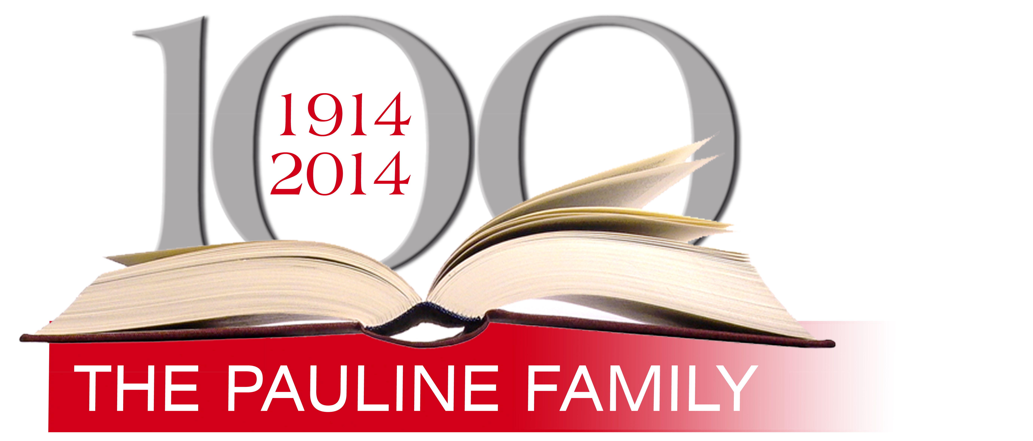
August 2013- November 2014

“VIA HUMANITATIS”
THE VOCATIONAL JOURNEY OF HUMANITY

SIXTEENTH OUTLINE November 2014

Called To Give Jesus to the World Like Mary

Guide: In giving us his Son, God the Father chose Mary as a cooperator in life and grace! It is wonderful to note how mutual exchange, the differences among individuals, etc., are opportunities for fecundity not only on the biological-human plane, but also in the spiritual and apostolic realms. This is also the great reality of the Pauline Family, which is composed of men and women who use the wealth of strength-weakness, vigor-compassion, paternity-maternity to proclaim Christ in a harmonious, creative and communal way: Fr. Alberione, Maestra Thecla, Timothy Giaccardo, Mother Scholastica…and all the sisters and brothers who in these 100 years collaborated, suffered and rejoiced together as befits a true Family!
During this time of prayer, let us ask Mary, the Mother of Jesus and our Mother–a Teacher of life, the Queen of Apostles and of every apostolate–to help us remain open to life, which for us means: collaboration, esteem, sharing, communion, loving one another, creating a family climate that is simple, warm and attentive so that young people who want to get to know us better will feel at home among us and will find space for reflection, a comparison of ideas, comfort and prayer. Let us ask that they might find in our communities responsible adults who rejoice in their vocation and are grateful to God for it.

Opening Hymn
From the Via Humanitatis

The Church is entrusted to Mary. In creation, in redemption, in the distribution of graces and in the order of glory, Mary occupies a preeminent place. She gives Jesus Christ to the world and to every person. She is the Mother of God and of the Church. All good things pass through Mary. From her comes life. She is our Mother.

Invitation to prayer

From the Letter to the Ephesians 1:3-14
(For accuracy of the Scripture text, we recommend that every community use the official Scripture edition used for the liturgy in each country.)

Scripture Reading

From the Gospel according to John 19:25-27
(For accuracy of the Scripture text, we recommend that every community use the official Scripture edition used for the liturgy in each country.)

From the Letter to the Galatians 4:4-5
(For accuracy of the Scripture text, we recommend that every community use the official Scripture edition used for the liturgy in each country.)

Canon

Listening to the Founder

Mary became Queen when she conceived the Divine Word and became his Mother. She was proclaimed Queen on Calvary. Mary exercised her queenship in the Upper Room. She was given the reward of a Queen at her blessed death. And Mary fulfilled [this role] and was crowned Queen of heaven by her divine Son. She now exercises her queenship forever in heaven. These are points on which we should continually reflect, always keeping in mind, however, that hers was a special kind of queenship.
Mary participates in the kingship of her Son, who is the king of minds, hearts and wills and, in a certain way, of our bodies themselves and our entire being. This gives rise to the following thought: that the glory shining in Mary’s most holy soul also shines in her body. She awaits her children at the resurrection so that they too can participate in the kingship of Jesus Christ. Just as we will be welcomed into the kingdom of Jesus Christ, so too will we be welcomed into the reign of Mary’s mercy.
When the angel told the Virgin that she would be the Mother of God, that she had been predestined for this lofty office, he reminded her of the kingship of the Son [she would bear], namely, that David was his father, reminding her of David’s faith and power: “He will reign over the House of Jacob forever and his reign will have no end.” The angel said that the subjects of this kingdom are all those who follow Jesus Christ: “He will reign over the House of Jacob” (Lk. 1:32-33). The Lord made Mary queen by reason of her virtue; she, in turn, she gave the world the Son of God Incarnate, and she gave him to the full. Everything we received through Jesus Christ we received from her: “We received life through the Virgin.” If we have the Master, if we have the Host, if we have the priesthood…they have all come to us through Mary. The same is true of every grace that humanity in general has received: the grace of enlightenment of the mind; the grace of supernatural feelings, of a new love that the Son of God brought from heaven, and the grace of holiness, of the perfect life. The Son of God brought this whole array of gifts from heaven and bestowed them all on us through Mary. Therefore, we participate in all the supernatural truths by means of which Jesus Christ reigns in our minds. We participate in the new love that has been given us in the heart of Jesus–that new love with which God, our heavenly Father, is to be loved. [We participate] in that uniformity, that intimacy, of the Incarnate Son of God with the Father: “This is my beloved Son” (Mt. 17:5). These are all things we should ponder at length.
Afterward, Mary was proclaimed Queen by her Son Jesus on the cross. More precisely, she was proclaimed Queen of the Apostles because on Calvary John represented the new generation–the generation of the children of God and thus [the Father’s] new children. First John was an Apostle…. Therefore, he represented the Apostles in particular. So Mary, our universal Queen, is Queen of the Apostles in a special way.
She exercised this office in the Upper Room when the Holy Spirit descended. Consequently, every election of grace and of the Holy Spirit that is given to humanity passes through Mary. The fact itself reveals that she is Queen of the Apostles: she encouraged the Apostles to pray and to hope. Through her prayers, which were accompanied by those of the Apostles, she hastened the coming of the Holy Spirit. We can almost say she hastened the beginning of the preaching of Jesus, who said: “My hour has not yet come” (Jn. 2:4). But Mary made the hour of Jesus strike and he “began to perform his signs” (cf. Jn. 2:11) by working a miracle at Cana. […]
Let us see to it that knowledge of the title “Queen of the Apostles,” the reasons we attribute it to Mary and also the effects and the fruits of this title penetrate [society] at the dawn of this [present] time. We, her children, have the special responsibility to remember, inculcate and preach this title. If certain fruits are lacking in the apostolate, perhaps the reason is precisely this failure on our part…. We must love the Queen of Apostles more so that we, in our turn, will know what is best to give those to whom we must communicate supernatural goods.
We will better understand the Master when we better understand our Queen, who is also our Mother and Teacher. When a priest more fully understands how Mary is the mother of humanity, then he will become a father to souls to a greater degree. When he more fully understands Mary’s role as Teacher, he will become a more competent teacher. And when he more fully understands the title “Queen of the Apostles,” he will become a more fecund apostle.
When we say that everything passes through Mary, we mean everything that completes the human being, the Christian, the religious and the priest. That is to say, supernatural truths and our new feelings in Christ: perfect love for God and our neighbor. This perfect love of God is accomplished through religious profession and the apostolate. And then participation in the virtues that Mary practiced because there is no virtue we can consider that Mary did not practice fully and perfectly.
(Fr. Alberione, Queen of Apostles Sanctuary, Rome, 20 April 1958)

Silence – Reflection – Sharing

For the Sharing: Let us ask the Lord, through the intercession of Mary, to bless our Institutes with the gift of new vocations.

Let us pray

May you be blessed, my God.
As natural life comes from our mother,
so supernatural life comes from Mary.
She is the root that bears the flower;
she is the mother who gives the blessed fruit of her womb;
she is the dawn that heralds the sun.
Where Mary is, there too is Jesus.
Whoever finds the Mother, also finds the Son.
Through Mary, the way is short and secure.
Jesus precedes us with his example:
he became the son of Mary.

Glory to God in the highest, and peace to all those of good will.
Jesus Master, Way, Truth and Life, have mercy on us.
Mary, Queen of Apostles, pray for us.

Concluding hymn

